Week13 to perform Database operations from JAVA Application through JDBC API

Need sql server 8 and above version for this.Search for mysql

Need Mysql workbench 8.0 to be installed in your systems

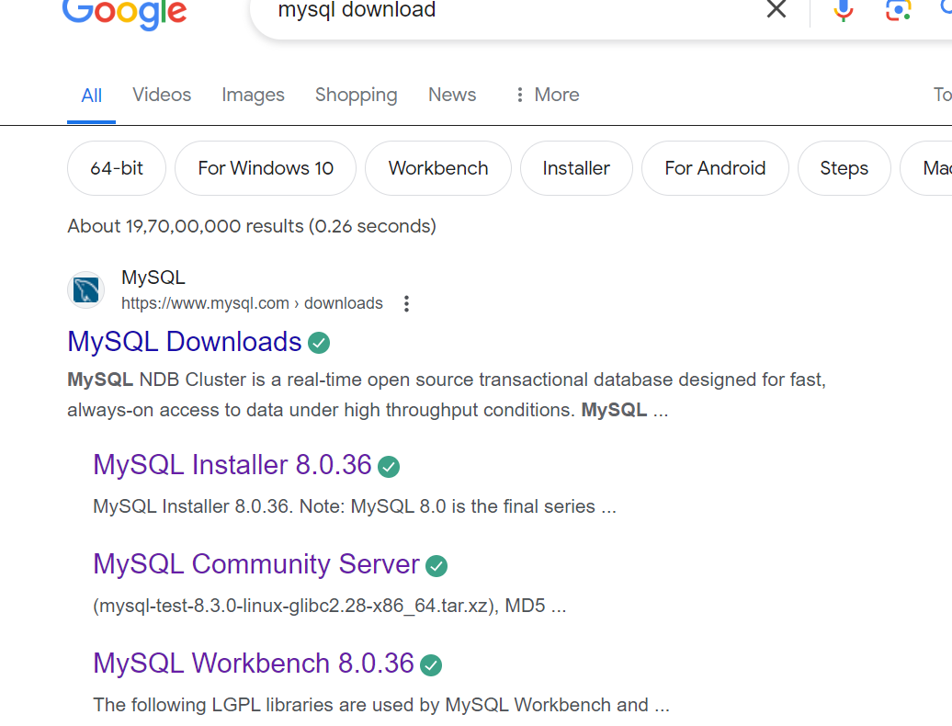



Set env variable path as below:

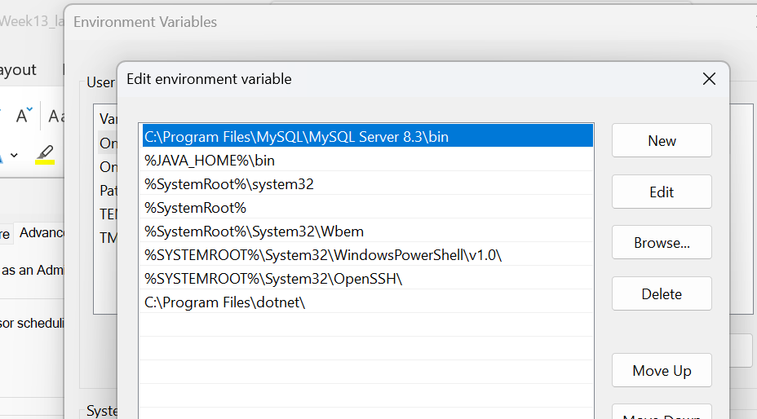

Install mysql workbench 8.0

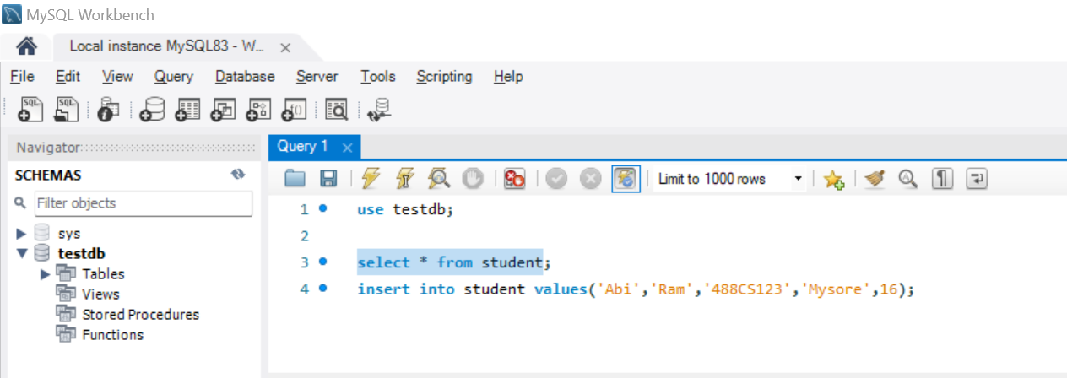

Next java program to register driver,establish jdbc connection to backend sql db and execute the query to retrieve data .

Filename:MySQLCon.java

**package** week13;

**import** java.sql.*;

**public** **class** MySQLCon {

**public** **static** **void** main(String[] args) {

**try** {

Class.*forName*("com.mysql.cj.jdbc.Driver");

// here testdb is database name, root is username and password@123 is the

// password )

Connection con = DriverManager.*getConnection*("jdbc:mysql://localhost:3306/testdb", "root", "password@123");

Statement stmt = con.createStatement();

ResultSet rs = stmt.executeQuery("select * from student");

**while** (rs.next()) {

System.***out***.println(rs.getString("firstname") + " " + rs.getString(2) + " " + rs.getString(3) + " "

+ rs.getString(4) + " " + rs.getInt(5));

}

} **catch** (SQLException ex) {

ex.printStackTrace();

} **catch** (ClassNotFoundException e) {

e.printStackTrace();

}

}

}

Run the program you will get class notfound exception or any other exception for that follow below step:

Need to place mysql-connector-java-8.0.19 in the eclipse classpath as follows:

Your Javaproject->rightclick->select BuildPath->Configure Build Path

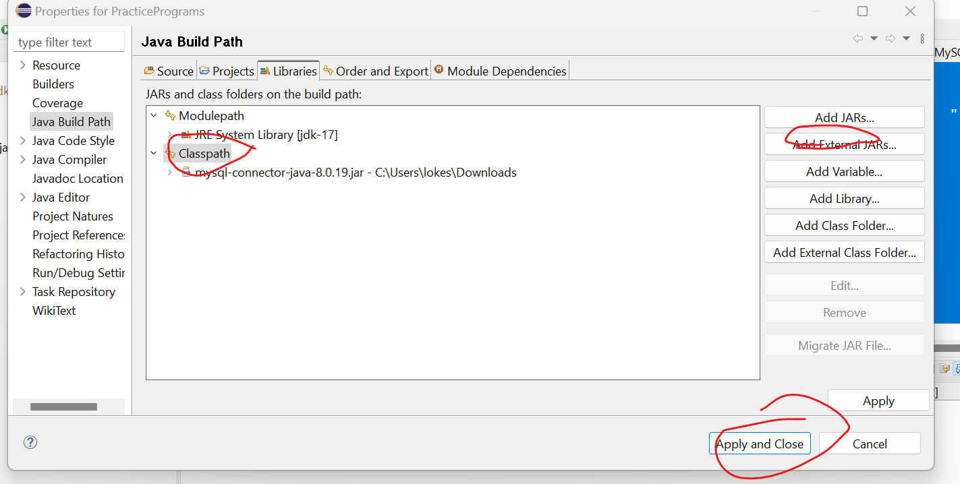

Now run the program which display the data from student table.